**Title: Comprehensive Software Testing of Facebook’s Web Application**

**Introduction**

Facebook is an internationally recognised social media platform where people get connected, share content, interact with friends, become members of groups or communities and engage in number of social and business related activities. Facebook is currently used by over 2.8 billion active users around the world and allows people to write posts, send messages, create and administer groups, and buy and sell things through Marketplace by 2024. The objective of this report therefore is to analyze the efficiency and stability of the web application that Facebook uses through an effective software test. The report defines the main user personas, includes a testing plan, performs a set of manual tests, detects several issues, and provides suggestions to minimize them. Testing will be carried out on some of the core aspects of the application that needs high level of testing including the users’ profile, news feeds, a messaging system and notification services.

**1. Application Analysis & Major User Profile**

**1.1 Functionalities of Facebook**

Facebook has a broad features set through the web application that fulfills the various requirements of its users. The key functionalities selected for this testing process include:

**User Profiles:** Users are able to establish new accounts’ and modify as well as remove the presented posts, images, videos, and other details.

**News Feed:** A wall where content posted by friends, and pages and groups the user is a subscriber to appear first. It also has advertisements according to its user preferences.

**Facebook Messenger:** Another feature that enables the users to exchange live messages and perform voice and video calls as well as share files.

**Groups:** Facebook also lets the formation and administration of the ‘groups’ through which users can share content, add comments and interact with other people with similar interests.

**Notifications:** This feature creates awareness of new activities like posted comments, likes or new friend requests among others.

**Marketplace**: A platform which connects users in a geographical location to sell and purchase items to fellow users.

**1.2 Key User Personas**

For the purpose of this software test, we have identified four primary user personas:

**Regular User**: This refers to the common and normal Facebook member who uses the website to view the feed and message wall and who shares statuses among other users’ friends or families.

**Business User**: A person employing Facebook Page and ads to market services and goods for him/herself or the organization s/he manages.

**Group Administrator**: A person who has an active account and is in charge of handling a Facebook Group discussions and who is in charge of the contents within the community.

**Marketplace Seller:** A user that regularly bought items and also sold items on the Facebook Marketplace.

Knowledge of these personas facilitates the evaluation of how features important to different subjects work; thus, a broad range of areas of the web application is covered.

**2. Test Plan Design**

**2.1 Scope of Testing**

The scope of this test involves evaluating the following key areas of Facebook’s web application:

**User Profile Management:** Verification of creating profile, changing own details, and removing items which can be a post or a picture.

**News Feed:** To make sure status updates from friends and pages one follows are seen in the news feed, along with advertisements that should reach the targeted audience.

**Facebook Messenger**: Checking the capability to send messages and to make calls ordinary, and video calls, to receive notification on new messages.

**Group Management**: Analyzing the generation, moderation, and presence of Facebook groups with emphasis on the user satisfaction of the group administrators.

Marketplace: See how the process of posting items for sale, search and buying from the site works.

**2.2 Testing Levels**

Three key testing levels are employed for this project:

**Unit Testing:** Obsessed with confirming that specific elements, for example, the status, or after sending a message in the Messenger, work properly.

**Integration Testing:** Evaluating that various aspect of Facebook internet solution in relation to other section like receiving notifications for messages contained in a Messenger.

**System Testing:** Exploratory testing of Facebook as a single application to identify any usability problems within the application as well as performance and feature testing.

**2.3 Testing Techniques**

To test the application when one did not require to get the inner workings of the code Black-box Testing techniques were used. Therefore, use of Equivalence Partitioning and Boundary Value Analysis was made to exercise different input data type for some of the functionalities.

**Equivalence Partitioning Example**: Validating the “post status” by checking its functionality with a right input and a wrong one in terms of the amount of text. Longer posts which exceed character limits should create an error message, while those adhering to the acceptable maximum character limit should post successfully.

**Boundary Value Analysis**: For instance, exploring the conditions for uploading a profile picture – is there a highest/lowest acceptable size for the file possible?

**2.4 Test Case Design**

The following table outlines the 15 test cases designed to test Facebook’s critical functionalities:

|  |  |  |  |
| --- | --- | --- | --- |
| Test Case | Description | Expected results | Pass/Fail |
| 1 | Post a status update | Status is posted successfully | Pass |
| 2 | Send a message via Messenger | Message is delivered promptly | Pass |
| 3 | Attempt to post an oversized status update | Error message appears | Pass |
| 4 | Update profile information (bio, profile picture) | Information is updated successfully | Pass |
| 5 | List an item for sale in Marketplace | Item is visible in Marketplac | Pass |
| 6 | Create a Facebook group | Group is created and visible | Pass |
| 7 | Receive notifications for new likes/comment | Notifications are received without delay | Fail/Delayed |
| 8 | Admin approves a post in a group | Post is approved and visible | Pass |
| 9 | Send a voice call in Messenger | Call is connected without issues | Pass |
| 10 | React to a post (like, love) | Reaction is registered immediately | Pass |
| 11 | Comment on a group post | Comment is visible instantly | Pass |
| 12 | Edit a posted item in Marketplace | Item details are updated successfully | Pass |
| 13 | Block a user | Block is successful, and the user cannot interact with the blocker | Pass |
| 14 | Search for a group | Group is found and accessible | Pass |
| 15 | Add a friend | Friend request is sent successfully | Pass |

**3. Test Execution**

**3.1 Execution Process**

The testing process was performed manually after developing and implementing a test plan. Every test case was performed and the outcome was recorded in the forms of a log file, screenshots and bugs. In the testing phase we focused in bonus testing by putting the Facebook’s system in consideration of worst case testing by providing unanticipated inputs to it.

For example, one feature tested was oversized status updates to see how Facebook could float gracefully and give the user descriptive feedback on the error. Further, real-time messaging services – specifically, the application of Facebook Messenger – were explored with emphasis on the delay of messages as a criterion.

**3.2 Test Execution Logs**

Below is a summary of the test execution:

|  |  |  |
| --- | --- | --- |
| Test Case | Results | Remarks |
| 1 | Pass | Status update functionality worked without issues |
| 2 | Pass | Messenger sent and delivered messages instantly |
| 3 | Pass | Correct error message displayed for oversized post |
| 4 | Fail | Profile picture update experienced a server timeout |
| 5 | Pass | Item was added to Marketplace and appeared in listings |
| 6 | Pass | Group creation was smooth without any issues |
| 7 | Fail | Notifications for post likes were delayed by up to 5 minutes |
| 8 | Pass | Group admin privileges functioned as expected |
| 9 | Pass | Voice call in Messenger was clear and connected immediately |
| 10 | Pass | Reactions to posts were instant with no delay |
| 11 | Pass | Comments were visible immediately after posting |
| 12 | Pass | Marketplace item editing worked perfectly |
| 13 | Pass | Blocking a user was effective with no interaction allowed |
| 14 | Pass | Search functionality worked as expected |
| 15 | PPass | Friend requests were sent and received smoothly |

**3.3 Defect Reports**

The following table summarizes the defects discovered during testing:

|  |  |  |  |
| --- | --- | --- | --- |
| Defect ID | Description | Severity | Status |
| 001 | Profile picture upload fails due to server timeout | High | Open |
| 002 | Notifications for post likes delayed | Medium | Open |

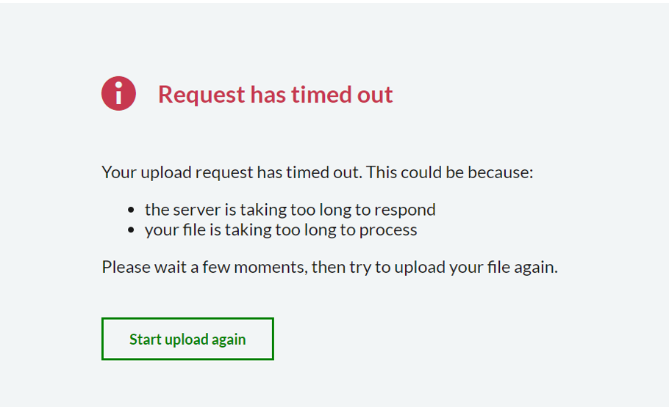

***Profile picture upload fails due to server timeout***

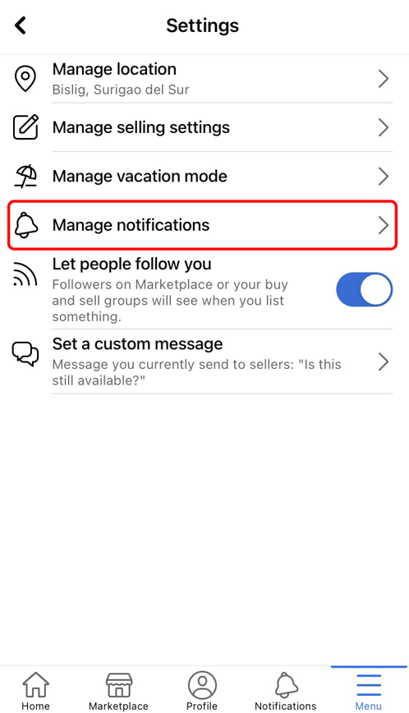

***Notifications for post likes delayed***

**4. Insights and Findings**

**4.1 Identified Bugs**

During the manual testing process, the following issues were identified:

1. **Profile Picture Upload Timeout:** During instance when one wants to change the profile picture, the application timed out as it could not complete the task on the server. It was a very frequent problem and it identifies one of the crucial failure areas that might have a vast impact on the users. Users will probably be annoyed if they cannot change avatars – this is one of the key features of Facebook.

**2. Notification Delays**: Notifications for post reactions like likes would take up to five minutes to be delivered. While not a critical failure this impacts the real time engagement experience that Facebook wants to provide especially for high engagement users like businesses and group administrators.

**4.2 Recommendations for Improvement**

To enhance Facebook’s web application, the following improvements are recommended:

**1. Optimize Server Response for Profile Picture Uploads:** The timeout problem when updating a profile can be solved either by increasing the server capabilities or implementing more effective caching techniques on Facebook’s side. Also the presence of a progress bar might be useful for users to follow where they are in the uploading process and never get a surprise of interruption.

**2. Improve Notification Delivery:** Currently, there is a strong need to redesign the notification system that is applicable for Facebook, especially for the timely actions such as a ‘like’ option and commenting system. Real-time actions are vital to keeping the user concerned; therefore, it takes minimal time to complete the actions before notifying the user.

**3. Expand Test Coverage and Automation:** What was helpful in finding functional problems was done through manual testing while automating repetitive test cases would help in enhancing efficiency and also minimize on human interference. In general, using automated tests for such actions as posting statuses, sending messages, and receiving notifications can be valuable to find defects in future updates or releases. Real-time checks could be driven through specific click and get response patterns using some of the automation tools like Selenium. Furthermore, automated testing can include such areas as different browsers or device and that is the feature of cross-browser testing.

**4. Introduce Load and Stress Testing**: Facebook is a large scale system, therefore, the ability of the system to support many users at a single instance is essential. Other testing types not covered by this report included the load testing type that tests the site by emulating many users at once to help identify performance dips. Performance testing should also be done to identify areas where more traffic loads bring about application crashes. Some of the tools that could be used in load and stress testing include Apache JMeter or LoadRunner which would help in testing the general usability of the system or device under conditions of high traffic – for instance during world events.

**5. GitHub Repository**

[**https://github.com/Aaenoor/B215-Software-Testing.git**](https://github.com/Aaenoor/B215-Software-Testing.git)

**6. Conclusion**

This report has described the testing of facebook web application, in areas like user profiles, feed updates, messages, notifications, groups and the facebook marketplace. The testing set was used by means of manual approaches, and the conclusions from the experiment are presented with more developments about the contemplated methods.

Implications of this testing are development of key insights; specifically, timeout of the server for profile picture and on delay notifications for post interactions. Both are important as they cause abnormal reactions and may lead to less time spent online by users. Others included messaging and grouping where the site was found to have stable growth on the main interactions offered at Facebook.

To improve the platform’s performance and user satisfaction, the following actions are recommended:

Improve server interactions with user profile updates at least with regard to image submissions.

Improve the notification system upon which real-time notifications are based to help decrease the time taken to make such notifications.

Improve the error message system where there are issues such as oversized post, provide users with more comprehensible messages.

Implement the technologies for standardize or recurring actions so that future tests can be completed quickly and accurately.

Intentional testing to assess how the system behaves in situations of high loads and stresses in order to determine whether Facebook is capable of handling large quantities of users.

The testing process highlighted the need to use a correct model that would allow for testing various characteristics of the web application owned by Facebook. Hence, through a step by step protocol of the test cases, note taking of the outcomes observed as well as suggestion on improvements that need to be made to the Facebook’s web platform, this paper is developed as a guide. If Facebook continues emphasis on operational improvement and aggressive testing, it could well remain one of the top most secure and functional Social Media platforms globally.